Snehan Gorain

Exploring Computer Engineering

TEJ1op:01

Semester 1

2014-2015

Mr. Buffone

Acronyms

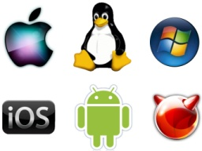

**OS- Operating System** The most important system that runs on a computer and is necessary to run basic programs. It controls your computer’s basic tasks and data. Instructs the computer how to operate.



**DVD- Digital Versatile Disc** A disc used for storing large amounts of data. It is used frequently for storing videos and music. That data on a DVD is accessed by a DVD player and a DVD drive. designed to hold movies or multimedia.

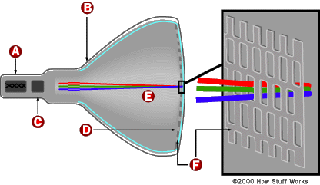

**CRT- Cathode Ray Tube-**  A vacuum tube in which Cathode rays create images on a fluorescent screen. Used often for TV screens.

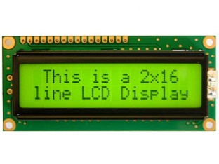

**LCD- Liquid Crystal Display-** A LCD is a thin and compact display where an electrically reactive substance is put between two electrodes. The colour of the substance can be changed by the electrical current.

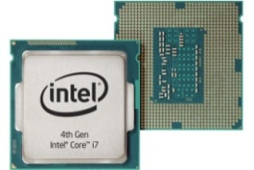

**CPU- The Central Processing Unit-** The CPU is used to process data from the computer. After the CPU has processed the data (keys, mouse clicks…etc), it presents the information ba ck to you.

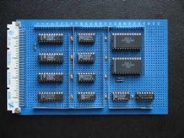

**ALU- The Arithmetic Logic Unit-** The ALU is the part of the computer used to perform calculations and make decisions.

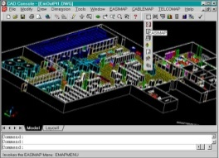**CAD- Computer Aided Design-** Computer- Aided Design is the use of computers to create 2D and 3D designs, such as two dimensional layout designs and three dimensional modeling.

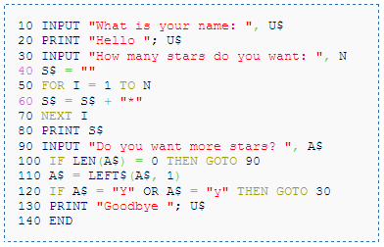**BASIC- Beginner’s All Purpose Symbolic Instruction Code-** A general purpose, high level programming language used on microcomputers that is easy to understand. It was especially popular during 1970-1980.

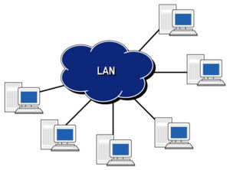

**LAN- Local Area Network-** LAN supplies networking capabilities to a group od computers in close proximity from each other. It allows these computers to share files, printers and applications.

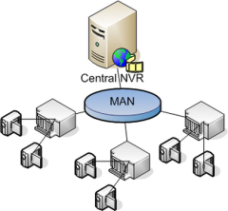

**MAN- Metropolitan Area Network-** MAN is a large computer network that spans throughout a specific geographic location, connecting all the computers in the area.

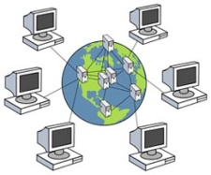

**WAN- Wide Area Network-** WAN is similar to LAN and MAN but much larger in size and is not limited to a single location. Many WAN networks span long distances via telephone lines, fiber-optic cables, or satellite links

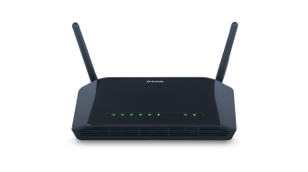

**MODEM- Modulator- Demodulator-** A device that converts the digital signal from a computer to an analogue signal that can be transmitted through a telephone line.

**DOS**

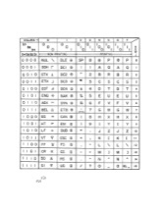**ASCII- American Standard Code for Information Interchange-** ASCII character encoding provides a standard way to represent characters using numeric codes, including upper-case and lower-case letters, numbers and punctuation symbols.



**LED- Light Emitting Diode-** A light emitting device that that produces light whenever a light is passed through it. LED’s can produce several different colours.

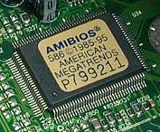**ROM- Read Only Memory-** Memory containing hardwired instructions which is used by the computer when it boots up before the system software loads. Permanent memory. Placed by the manufacturer.

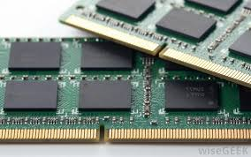

**RAM- Random Access Memory-** Made up of small memory tubes that form a memory module. These modules are installed in the RAM slots on the motherboard of the computer. It gets loaded every time after opening a program. Temporary memory for current use by the processor. Very volatile. Info lost after power is tunred of.

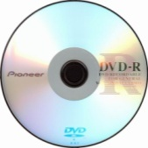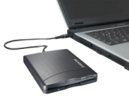**DVD-R- Digital Versatile Disk Recordable-** A DVD-R is similar to a CD-R. It is like a DVD, but it can be used to store data. Once a DVD-R is burned/written to, it can not be written to again

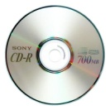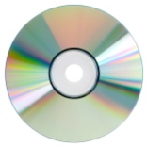**DVD-RW- Digital Versatile Disk Re-Writable-**  A DVD-RW is like a DVD-R, however unlike a DVD-R, it can be erased and new data can be added. They do not come in double-sided or double-layered versions like DVD-R’s.

**CD- Compact Disk-** CD’s are circular disks 12cm in diameter and can hold up to 700MB of data. An optical read disc designed to hold music.

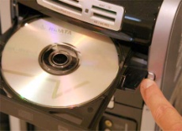**CD-R- Compact Disk Recordable-** A CD-R is a black disc that can record data by burning it. It is permanent. It cannot be erased. It is often used to record audio.

**CD-RW- Compact Disk Re-Writable-** A CD-RW ia blank CD that can be written to by a CD burner. Unlike a CD-R, a CD-RW can be written to multiple items. A CD-RW’s data can not be changed; it needs to be completely erased and add the changed data.

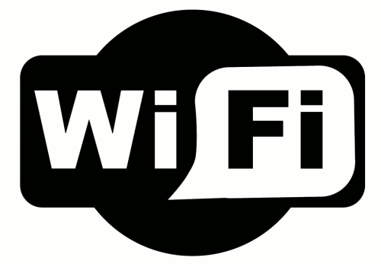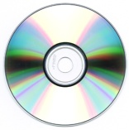**CD-ROM- Compact Disk Read Only Memory-** A CD-ROM is an optically read disc that can be read by a computer with a optical drive. Desgined to hold digital informations such as programs and data. It is read only, meaning the data can not be erased or altered. It is great for retail software.

**WI-FI-** Wi-fi is a networking technology that is used to communicate with other computers and devices over a wireless signal. It is the standard way computers connect to wireless networks.

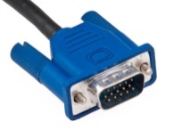

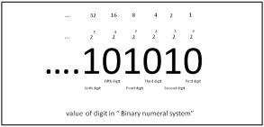**VGA- Video Graphics Array-** A VGA is the standard monitor is display interface used in most PCs. Therfore, if a monitor is VGA-compatible, it would work with most new computers.

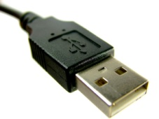**Bit- Binary Digit-** Bit is the smallest unit of measurement used to quantify data. They are grouped in clusters of eight. One cluster (of eight bits) is knone as a byte.

**USB- Universal Serial Bus-** USB’ s are the most popular sort of computer port used. It is used to connect keyboards, mice, game controllers, printers, scanners and removable media drives to name a few.

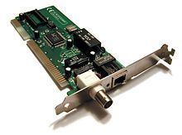

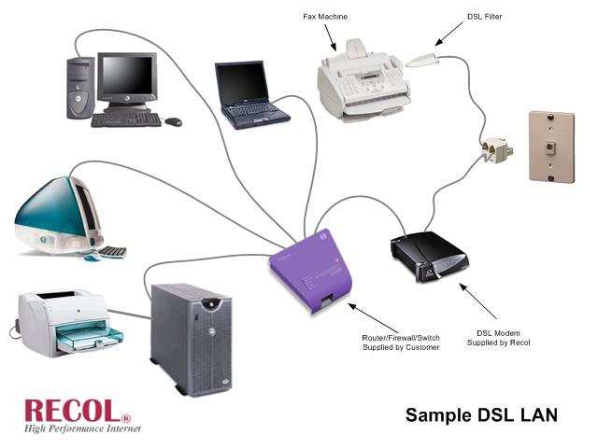**NIC- Network Interface card-** The NIC is the card used to make the connection between the computer and the network cable. These typically use an internet connection.

**DSL- Digital Subscriber Line-** The DSL is a communications medium used to transfer digital signals over standard phone lines.

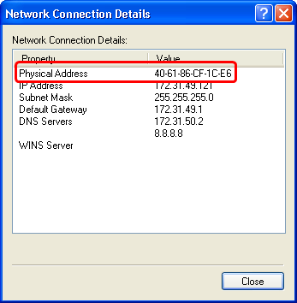**Mac Address- Media Access Control Address-** A hardware identofication number which identifies each device on a network.



**BMP- Bitmap-** A commonly used format for saving image files. Stores data for each pixel in an image without any compression.

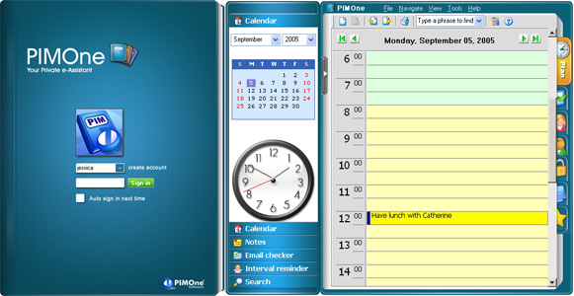

**PIM- Personal Information Manager-** A software application that serves as a planner, notebook and address book. It can also include features such as a clock, photo album and calculator.

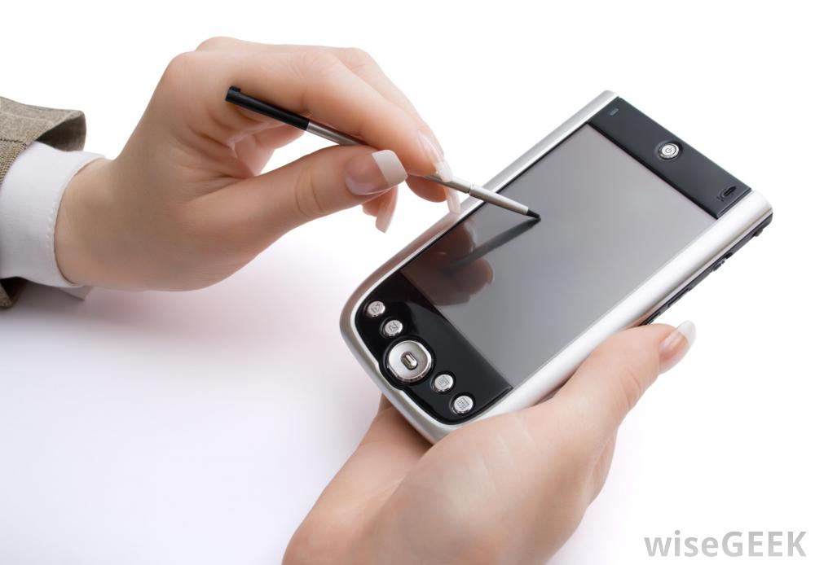

**PDA- Personal Digital Assistance-** A portable hand-held device that combines computing, telephone/fax, internet and networking features.

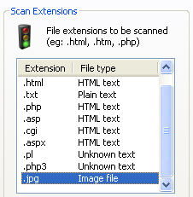

**JPG (JPEG)- Joint Photographic Experts Group-** A compressed image file format. They are not limited to a certain amount of colour like GIF images are, therefore it is the best format for compressing images.

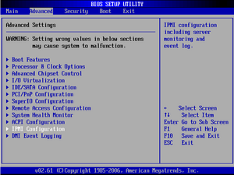**BIOS- Basic Input/Output System-** The BIOS is a pre-installed program on all windows based computers used to start up the computer. The CPU accesses accesses the BIOS before the operating system is loaded. The BIOS then checks all hardware connections and locates all devices. The BIOS loads the operating system into the computer’s memory and finishes the boot up process.

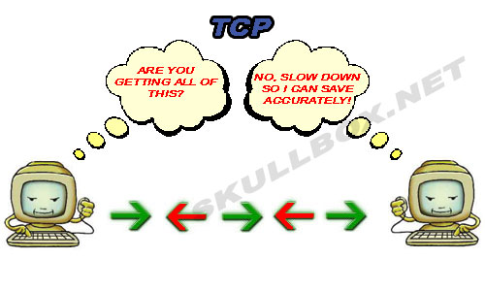**TCP- Transmission Control Protocol-** Allows computers to communicate over long distance networks. The TCP has to do with the verifying delivery of the packages whereas IP refers to moving packets between nodes.

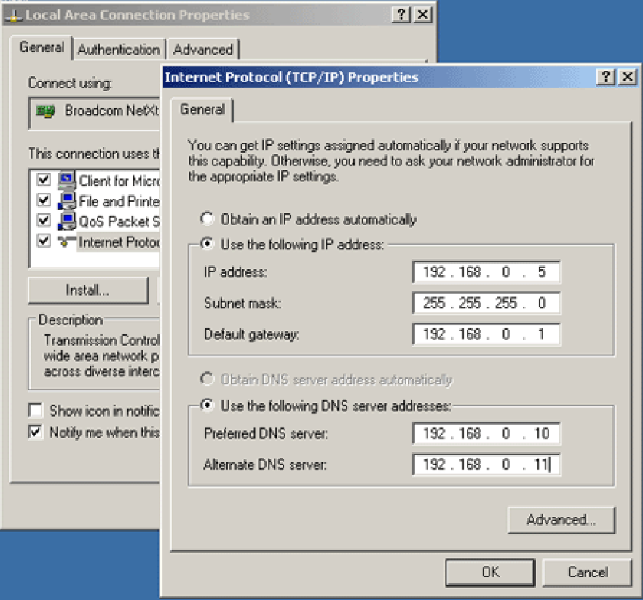

**IP- Internet Protocol-** Provides a standard set of rules for sending and receiving data through the internet.

**GIGO- Garbge In Garbage Out-** Invalid data is entered in a computer program, therefore with the output being invalid.



**WWW- World Wide Web-** A subset of the internet. Consists pages that can be accessed by the web browser.

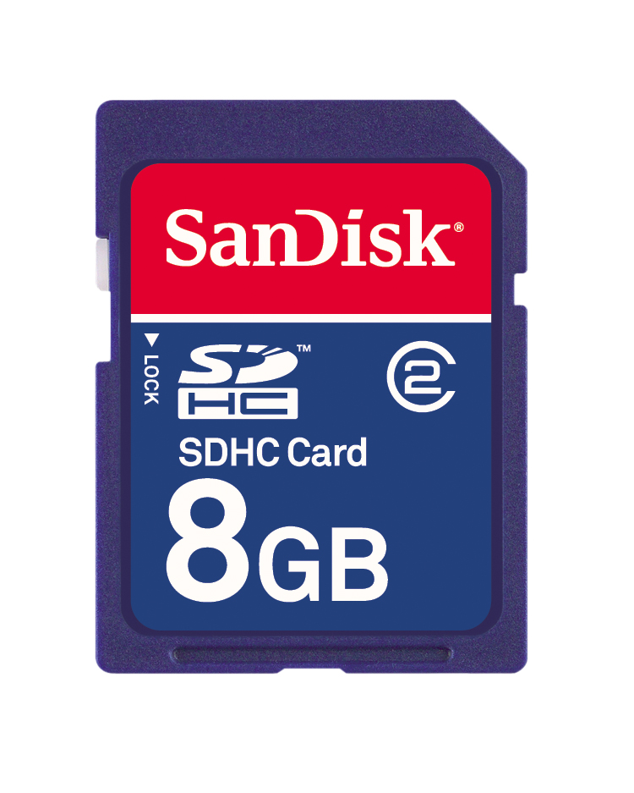**SD- Secure Digital-** A memory card used to store data in devices such as digital cameras, PDAs, mobile phones,portable music players and digital voice recorders.

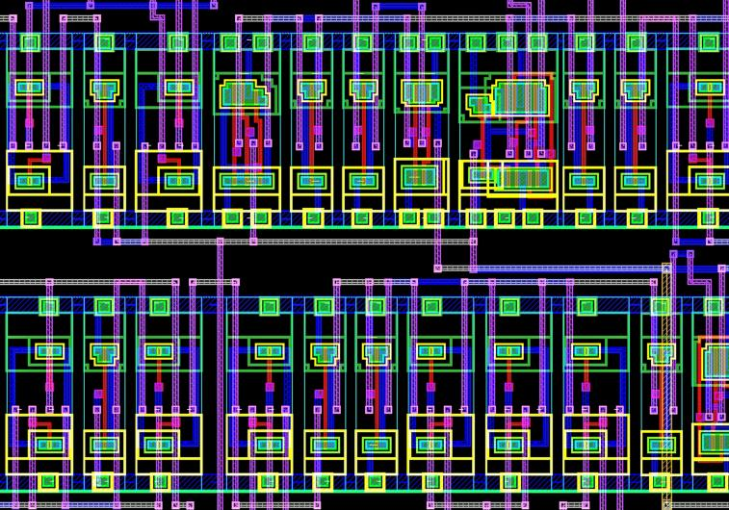**IC- Intergrated Circuit-** A small chip that can function as an amplifyer, oscilattor, timer, microprocessor or computer memory. It is a small wafer typically made of silicon and can hold anywhere from hundreds to millions of transistors, resistors and capicators. These electronics store data and perform calculations using either digital or analoque technology.

**NFC- Near Field Communication-** NFC is a short-range wireless conectivity technology. It makes use of interacting electromagnetic radio fields instead of the regular Direct Radio Transmissions, which is used by bluetooth.